VISHWAKARMA INSTITUTE OF INFORMATION TECHNOLOGY, PUNE

COMPUTER ENGINEERING DEPARTMENT

APRIL-MAY 2018

Synopsis



Group number:

Group Members:

1. Janavi Shah

2. Prachi Panjwani

3. Farah Pankhania

4. Anish Oswal

Email-ID : janavi.shah@viit.ac.in

Mobile no : 7875569882

Title: Software Development For Laser Marking Machine

Objective:

* To develop software for laser marking machine to control its working.
* Software for automating the process.
* Real-time error detection and alert eruption.

Abstract:

Laser Marking Machine are used for marking entities on the work piece. The software is developed for laser marking machines. These machines are used for marking on different materials like metal, wood, etc. They use a laser source which emits laser on the material where marking is to be done. Previously, the marking procedure was manual where switches and buttons were to start the marking. The job on which marking is to be done had to be aligned manually before starting the mark. The quality of the mark was defined manually and if the marked entity had errors, it had to be defined by the operator. It is a tedious process to perform these tasks by hand. Therefore, software development was required for controlling the work, analyzing the quality and introducing automation which would reduce the laborious work and bring efficiency in working hence saving a lot of time and man power

Briefs about Contents:

1. Introduction:

As mentioned before, the module has four parts.

The first part is development of HMI (Human Machine Interface) to control the machine. Herein user interface is developed where functionality is given to control the working of laser and gives result about the quality of the mark which will further be used for analysis to evaluate the performance of machine.

The second module is related to real-time monitoring for error detection and alert irruption. This module is developed to check for the probable errors that might occur and alert the supervisor/user/operator to rectify those errors.

The third module includes generation of QR Code for a category of products and then on scanning it will redirect to a webpage which will display the information regarding the product and will include some other functionalities for better customer service.

The final module is automation in marking. This module is developed to eliminate the need for the user to align the job on which marking is to be done. The software will calculate the positioning of the job in the workspace and mark accordingly.

1. Technical Details:

Client System

Operating System : Windows 7+

Database: sql+ database

Platform: Visual Basic, .NET Framework, SamLight Software

Hardware: SCAPS USC-1 Scanner Controller Card

Camera for detecting positioning of work piece.

1. Working:

Four different modules are to be developed.

To explain the working refer to the activity diagram given below 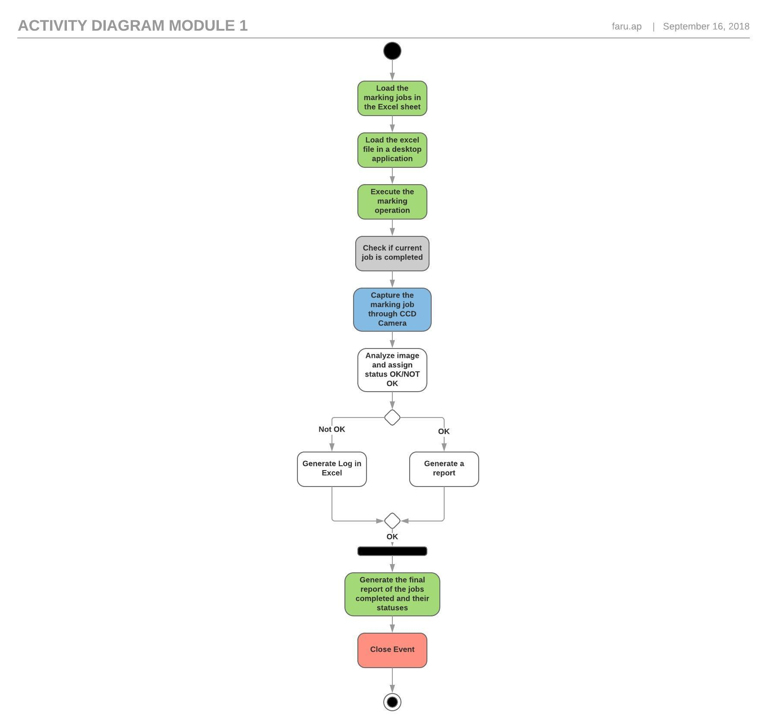

A close up of a map

Description generated with high confidence